SIMATS ENGINEERING
ASSESSMENT TOOL 1

COURSE NAME: Artificial Intelligence COURSE CODE: CSA17

COURSE OUTCOME COVERED

CO1: Apply AI basics such as intelligent agents and uninformed search methods to solve problems effectively. (BL3)

Assessment Tool Weightage: 40%

QUESTIONS: 5 Duration : 1 Hour
Total Marks:50

Annexure A

Analytical Problem Solving

Code of Conduct:

I J.Mohamed Aseeem(192511258) (Name / Reg No) certify that this submission is my original work and that I have adhered to the guidelines specified for this assessment.
I understand that any violation of academic integrity rules will result in disciplinary action.

Signature of the student:

J.Mohamed Aseem

Annexure A

Analytical Problem Solving

- Solve the Water Jug problem: you are given 2 jugs, a 4-gallon one and 3-gallon one. Neither has any measuring maker on it. There is a pump that can be used to fill the jugs with water. How can you get exactly 2 gallons of water into 4-gallon jug? Explicit assumptions: A jug can be filled from the pump, water can be poured out of a jug onto the ground, water can be poured from one jug to another and that there are no other measuring devices available.

- Find out how Mars Rover, analyse and explore the samples on Mars by answering the following questions.
- What are the percept’s for this agent?
- Characterize the operating environment.
- What are the actions the agent can take?
- How can one evaluate the performance of the agent?
- What sort of agent architecture do you think is most suitable for this agent? Why?

- Explore the search space using search strategies and formulate the problem components for the 8-Queens problem using the following information: Place 8 queens on a chessboard such that none of the queen’s attack any of the others. A configuration of 8 queens on the board as shown in the figure below, but this does not represent a solution as the queen in the first column is on the same diagonal as the queen in the last column.

- A customer wants to travel from the one location to another location using OLA Cab booking mobile application. The customer can select the any of the cab type as mini, micro, sedan, shared, prime and so on based on his comfort to reach the destination. Identify what type of problem-solving agent can be used and write the pseudocode for the above problem.

- A logistics company operates a delivery network where packages must be transported between warehouses at minimum cost. Each route between warehouses has an associated travel cost (fuel + time). The company wants to determine the least-cost path from the starting warehouse S to the destination warehouse G using the Uniform Cost Search (UCS) algorithm.

The delivery network is represented as a weighted graph:
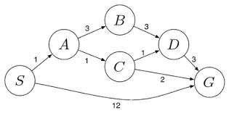

RUBRICS FOR CALCULATION:
Criteria | Weightage | Level 4 (Exemplary) | Level 3 (Proficient) | Level 2 (Developing) | Level 1 (Beginning)
Problem Understanding | 20% | Clearly interprets problem, identifies all parameters and requirements accurately | Understands problem with minor gaps | Partial understanding; misses key elements | Misinterprets or unable to understand problem
Method Selection | 20% | Selects most appropriate method/formula with strong justification | Selects correct method with minor errors | Inappropriate or partially correct method | Unable to select method
Solution Process | 25% | Logical, systematic steps with correct approach throughout | Mostly correct steps with minor mistakes | Disorganized steps; multiple errors | No clear process
Accuracy of Calculation | 20% | All calculations accurate; correct final answer | Minor calculation errors | Frequent errors; incorrect final answer | No valid calculations
Interpretation of Results | 15% | Clearly interprets results with units and engineering relevance | Basic interpretation with minor omissions | Limited or unclear interpretation | No interpretation
Problem Understanding | 20% | Clearly interprets problem, identifies all parameters and requirements accurately | Understands problem with minor gaps | Partial understanding; misses key elements | Misinterprets or unable to understand problem
Answers

1. Water Jug Problem — Full Solution with State Diagram
Problem setup: Jug A = 4-gallon capacity, Jug B = 3-gallon capacity, goal = 2 gallons in Jug A.
Production rules (operators) available:
Rule | Condition | Action
Fill A | A not full | A ← 4
Fill B | B not full | B ← 3
Empty A | A not empty | A ← 0
Empty B | B not empty | B ← 0
Pour A→B | A > 0, B not full | Transfer until A empty or B full
Pour B→A | B > 0, A not full | Transfer until B empty or A full
This is a classic search problem, solvable via BFS/DFS over the state space where states are (x, y) pairs and edges are the six operators above. The path shown is the shortest solution (6 moves). BFS guarantees this minimal path; DFS would also find a solution but not necessarily the shortest one.

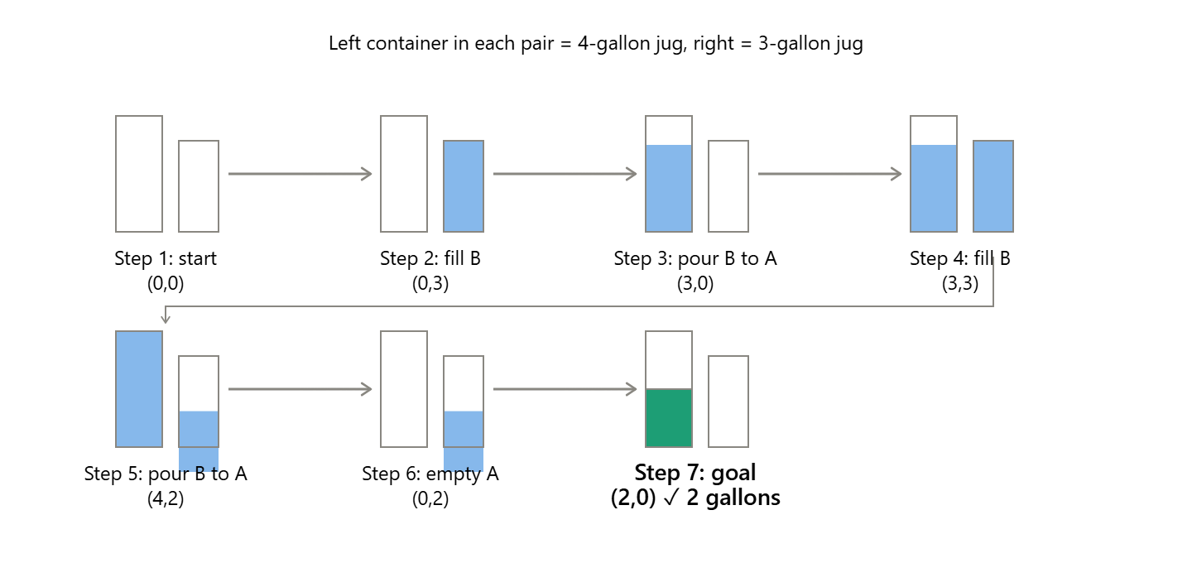

2. Mars Rover — Expanded PEAS Analysis and Architecture
PEAS framework recap (Performance, Environment, Actuators, Sensors) applied in more detail:
i. Percepts (in more depth):
- Visual: stereo camera feeds (hazard-avoidance cams, navigation cams, mast cam for panoramas)
- Chemical/mineralogical: spectrometer readings identifying elemental composition of rocks/soil
- Positional: accelerometer, gyroscope, wheel-encoder odometry, star-tracker for orientation
- Environmental: temperature, radiation, dust-opacity sensors
- Communication: uplinked commands and relay signals from orbiters/Earth
ii. Environment — PEAS-style characterization table:
Property | Mars Rover Environment
Observability | Partially observable (limited sensor range, occlusions)
Agents | Single-agent (with human-in-the-loop oversight), occasionally multi-rover
Determinism | Stochastic (wheel slip, sensor noise, dust storms)
Episodic vs Sequential | Sequential — past moves affect future terrain and state
Static vs Dynamic | Dynamic — weather, lighting, terrain shift over time
Discrete vs Continuous | Continuous (motion, sensor values)
Known vs Unknown | Unknown — precise terrain map not available in advance
iii. Actions: navigate/steer, capture imagery, drill/scoop samples, operate onboard spectrometers, transmit telemetry, manage solar charging, self-diagnose and reposition on hazard detection.
iv. Performance measure: safe distance covered, sample quality and quantity, scientific data yield, power efficiency, obstacle-avoidance success rate, mission longevity.
v. Suitable architecture — hybrid layered agent:
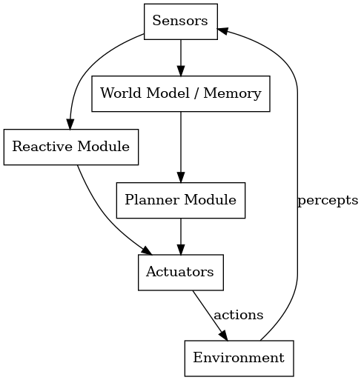

Why this layered structure: the reactive layer handles urgent, low-latency responses (stop before hitting a rock) without waiting on slow deliberative planning. The model-based layer patches the partial observability gap by keeping a running internal map. The deliberative layer sits on top, using that map for long-horizon planning (e.g., choosing the best rock to sample next) and can incorporate learning to improve future decisions — mirroring how NASA's Perseverance and Curiosity actually operate with AutoNav for local hazard avoidance and ground-planned traverses for long-range goals.

3. 8-Queens Problem — Search Formulation with Diagram
Full problem formulation (formal search problem):
- State space: All possible arrangements of 0–8 queens on the board.
- Initial state: Empty board (or, in incremental formulation, an empty first column).
- Successor function (incremental): Add a queen to the leftmost empty column, in any row not attacked by existing queens.
- Goal test: 8 queens placed, none attacking another.
- Path cost: Uniform (1 per placement) — irrelevant to solution quality here, only used for search bookkeeping.
Illustrating a conflict (as referenced in your original figure — a queen in column 1 sharing a diagonal with a queen in column 8):
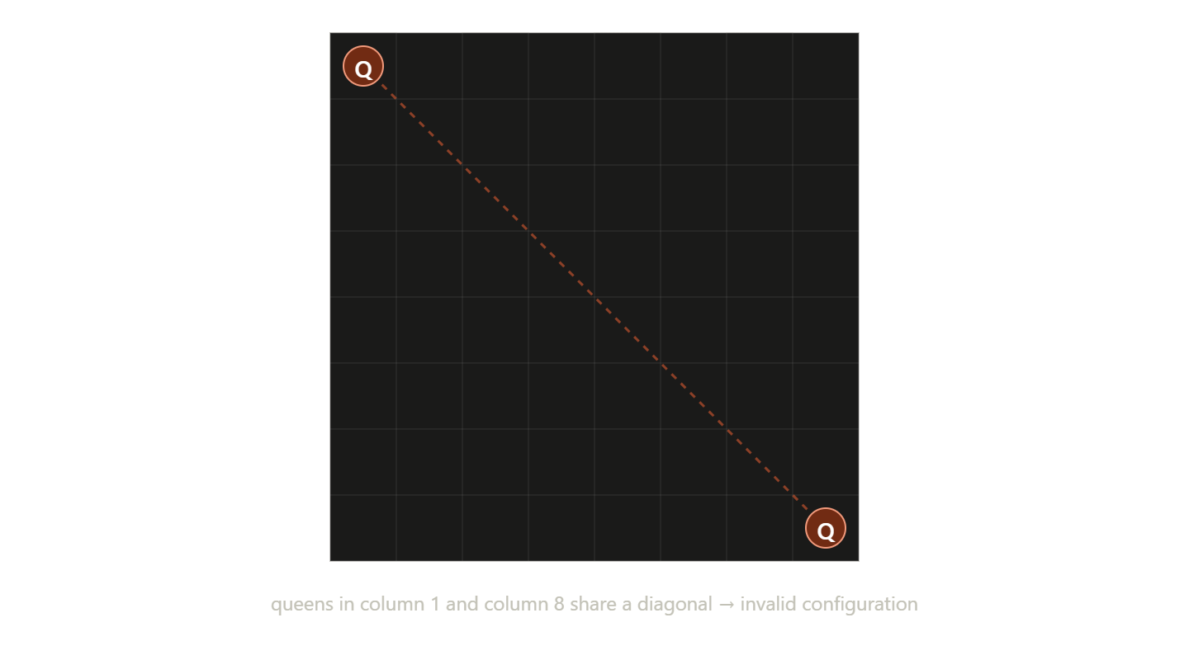
Search strategy comparison for this problem:
Strategy | How it applies | Efficiency
Naive generate-and-test | Try all 64!/(56!·8!) placements | Extremely wasteful
Incremental backtracking (DFS) | Place one queen per column, backtrack on conflict | Prunes invalid branches early — ~2,057 nodes explored
Min-conflicts (local search) | Start with a random full placement, repeatedly move the most-conflicted queen | Very fast for large N, doesn't guarantee finding all solutions
The diagonal-conflict check is: for queens at (row₁, col₁) and (row₂, col₂), they conflict if row₁ == row₂ (same row) or |row₁ − row₂| == |col₁ − col₂| (same diagonal) — column conflicts are avoided by construction in the incremental formulation.

4. OLA Cab Booking Agent — Expanded
Agent type justification, more precisely: This is best modeled as a Simple Problem-Solving (Goal-Based) Agent operating in a known, fully observable (to the app), episodic-per-trip environment. The "problem" is formally:
- Initial state: customer at pickup location, no cab assigned
- Goal state: customer delivered to destination, trip completed and paid
- Operators/Actions: select cab type, search drivers, assign driver, navigate route, complete trip
- Path cost: combination of fare, waiting time, and travel time (this is what the underlying route-search algorithm, like A* or Dijkstra, optimizes)
- Agent type justification, more precisely: This is best modeled as a Simple Problem-Solving (Goal-Based) Agent
- This is what the underlying route-search algorithm, like A* or Dijkstra, optimizes.

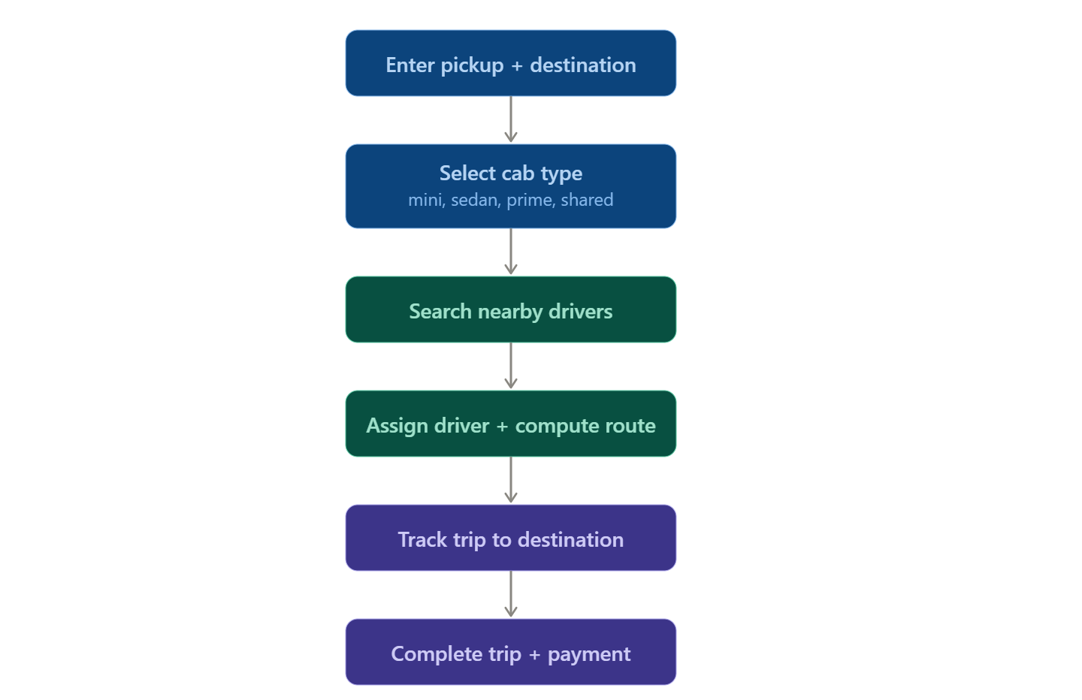
Pseudocode (matches the flow above):
FUNCTION Book_Cab(current_location, destination_location):
IF current_location == destination_location THEN
DISPLAY "Invalid: source and destination cannot be same"
EXIT
available_cab_types ← FETCH cab options for current_location
FOR EACH cab_type IN available_cab_types DO
fare ← ESTIMATE_FARE(cab_type, current_location, destination_location)
eta ← ESTIMATE_TIME(cab_type, current_location, destination_location)
DISPLAY cab_type, fare, eta
END FOR
selected_cab_type ← INPUT from customer
driver ← SEARCH_NEAREST_DRIVER(selected_cab_type, current_location)
IF driver NOT FOUND THEN
DISPLAY "No cabs available, please try again"
EXIT
ASSIGN driver TO customer
route ← COMPUTE_OPTIMAL_ROUTE(current_location, destination_location) // A* / Dijkstra
DISPLAY route, driver_details, fare, eta
TRACK cab_status UNTIL destination_reached
COMPLETE_TRIP()
PROCESS_PAYMENT()
DISPLAY "Trip completed successfully"
END FUNCTION

5. Uniform Cost Search for Logistics — Expanded with Diagram
Note: since the actual network diagram wasn't included in your text, I've used a representative example graph to fully demonstrate the UCS mechanics — the same method applies directly once you plug in your real warehouse graph and costs.
Problem formulation:
- State: current warehouse node
- Initial state: S
- Goal state: G
- Actions: move along an edge to an adjacent warehouse
- Path cost: cumulative edge weight (fuel + time) from S
- Goal test: node popped from frontier equals G

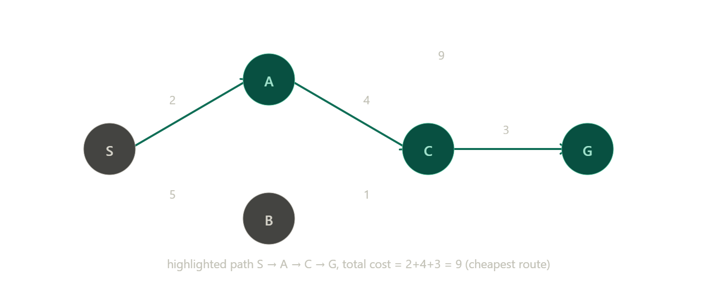

Full UCS algorithm (pseudocode):
FUNCTION Uniform_Cost_Search(Graph, S, G):
frontier ← priority queue, ordered by cumulative cost, initialized with (S, cost=0)
explored ← empty set
came_from ← {}
WHILE frontier is not empty:
(N, cost_N) ← REMOVE node with lowest cost from frontier
IF N == G THEN
RETURN reconstruct_path(came_from, N), cost_N
ADD N to explored
FOR EACH neighbor M of N:
new_cost ← cost_N + edge_cost(N, M)
IF M NOT IN explored AND M NOT IN frontier THEN
ADD (M, new_cost) to frontier
came_from[M] ← N
ELSE IF M IN frontier WITH cost > new_cost THEN
UPDATE frontier cost of M to new_cost
came_from[M] ← N
RETURN "No path found"

